# 

# IMPLEMENTING CRM FOR RESULT TRACKING OF A CANDIDATE

# WITH INTERNAL MARKS

## INTRODUCTION

**OVERVIEW**

This project helps to develop a result tracking of a candidate withinternal marks using salesforce. Salesforce is Customer Relationship Management application which is being used in almost all companies to have a friendly relationship with the customer.in our project. we have created a result tracking of a candidate withinternal marks.

**PURPOSE**

The internal assessment helps to give credit in the final assessment. Also, it reduces the burden and tension related to the final examination. In addition, it acts as a link which provides data related to student's performance. This gives teachers an opportunity to evaluate the students.

# PROBLEM DEFINITION AND DESIGN THINKING

## EMPATHY MAP

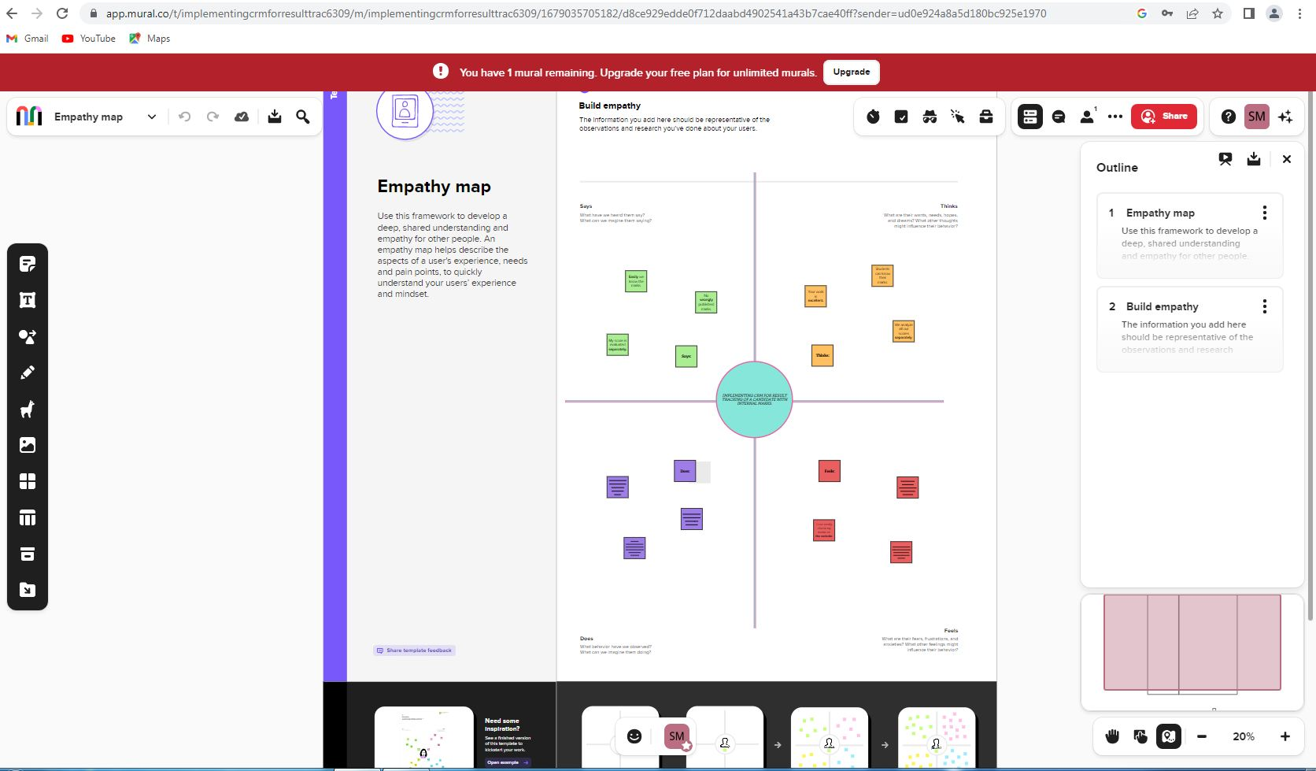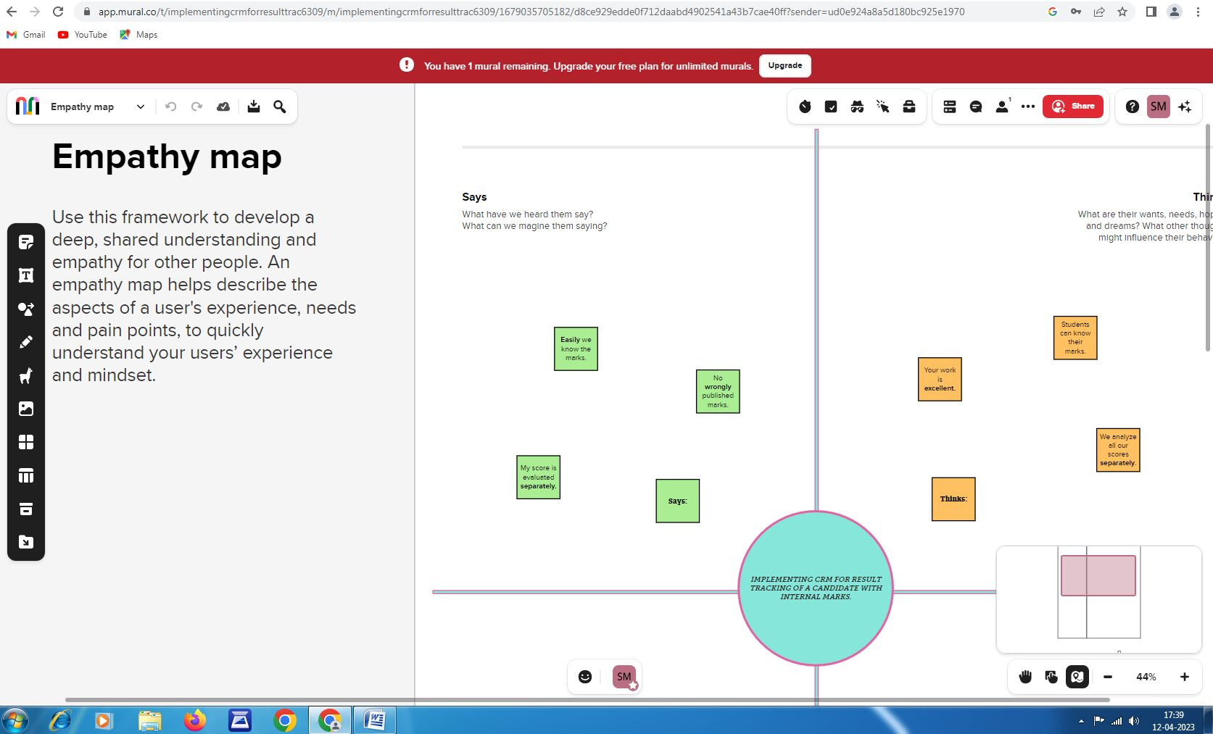

## IDEATION AND BRAINSTORMING MAP

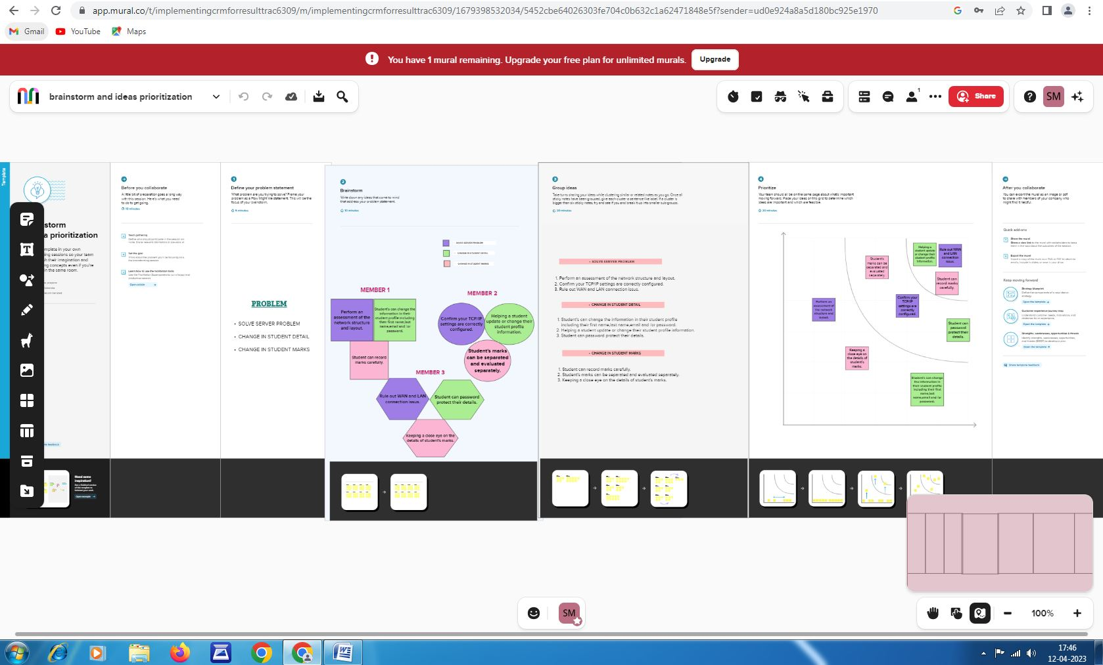

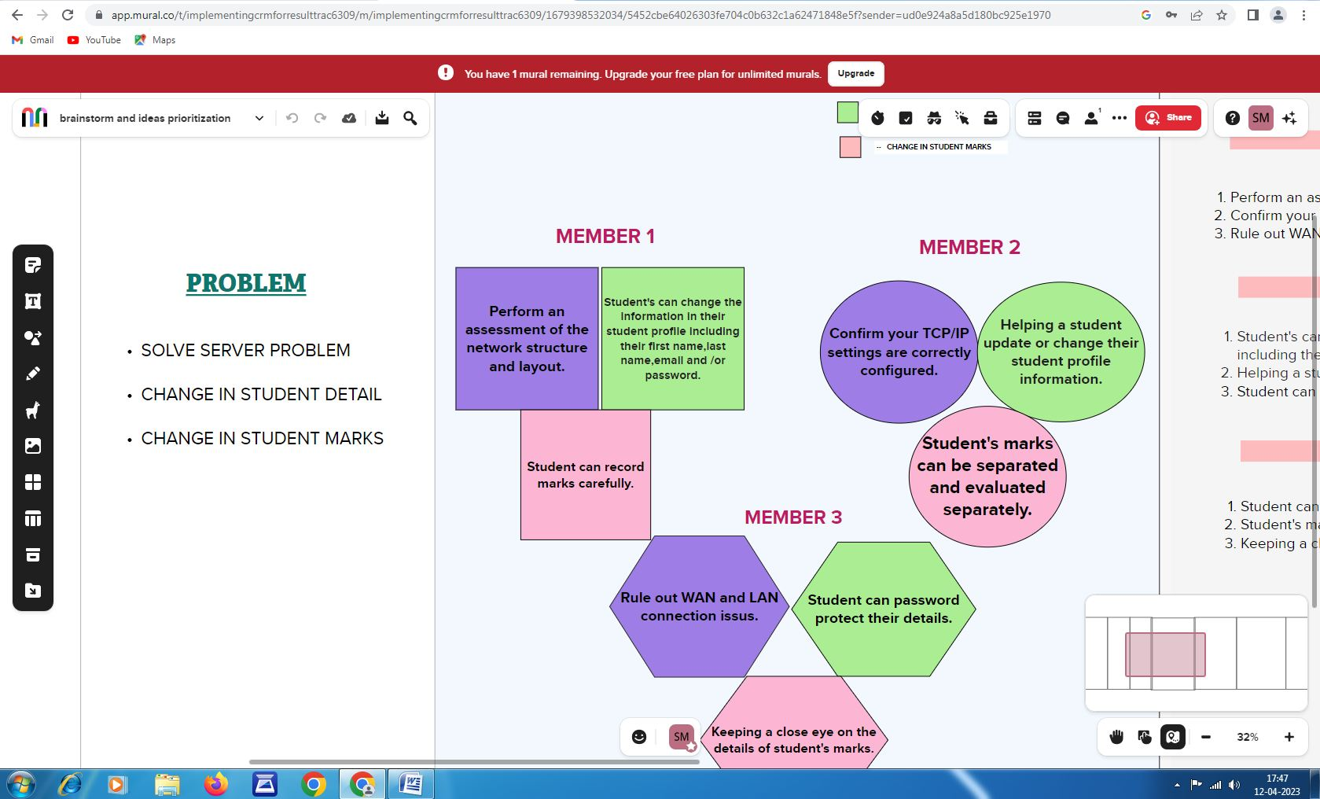

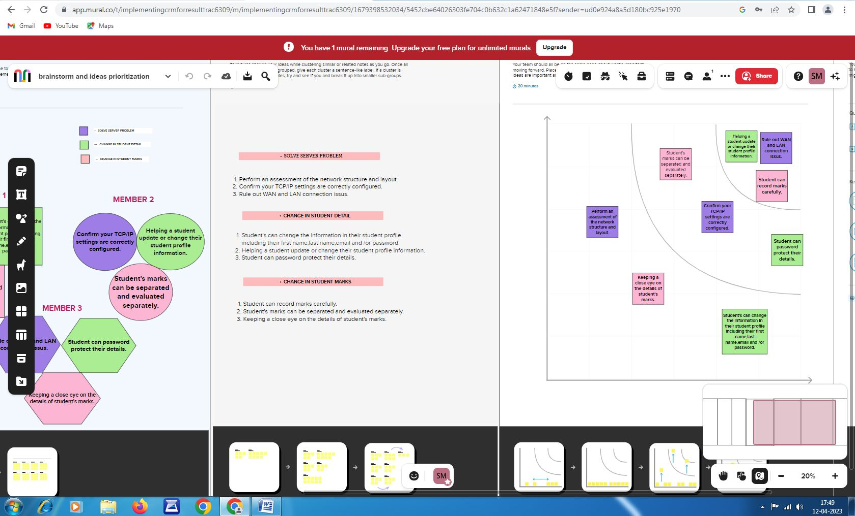**ACTIVITY AND SCREENSHOT**

## 1.CREATING AN SALESFORCE ACCOUNT

we went to the website developers.salesforce.com and signed up by giving our details

## LOGIN TO SALESFORCE ACCOUNT

we gave our username and password which we created in the last step and logged in into the salesforce account.

## OBJECT

Salesforce objects are database tables that permit you to store data that is specific to an organisation. Salesforce objects are of two types: Standard Objects: Standard objects are the kind of objects that are provided by salesforce.com such as users, contracts, reports,dashboards, etc.

**Custom objects:**

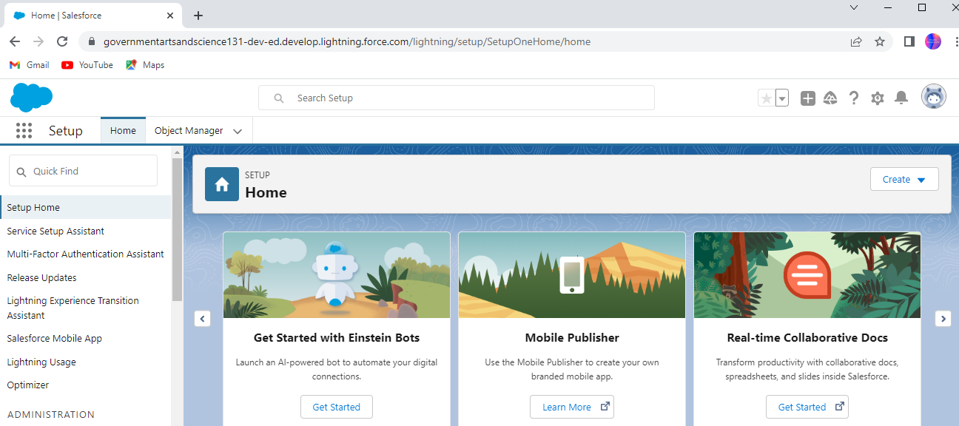 1.Semester

2.Candidate

3.Course Details

4.Lecturer Details

5.Internal results

**To Create an object:**

Creation of Objects for Candidate Internal Result Card, For this Candidate Internal Result Card we need to create 5 objects i.e Semester, Candidate,Course Details,Lecturer Details,Internal Results.

Follow Similar steps to create Candidate,Course Details,Lecturer Details,Internal results Objects.

**Candidate**

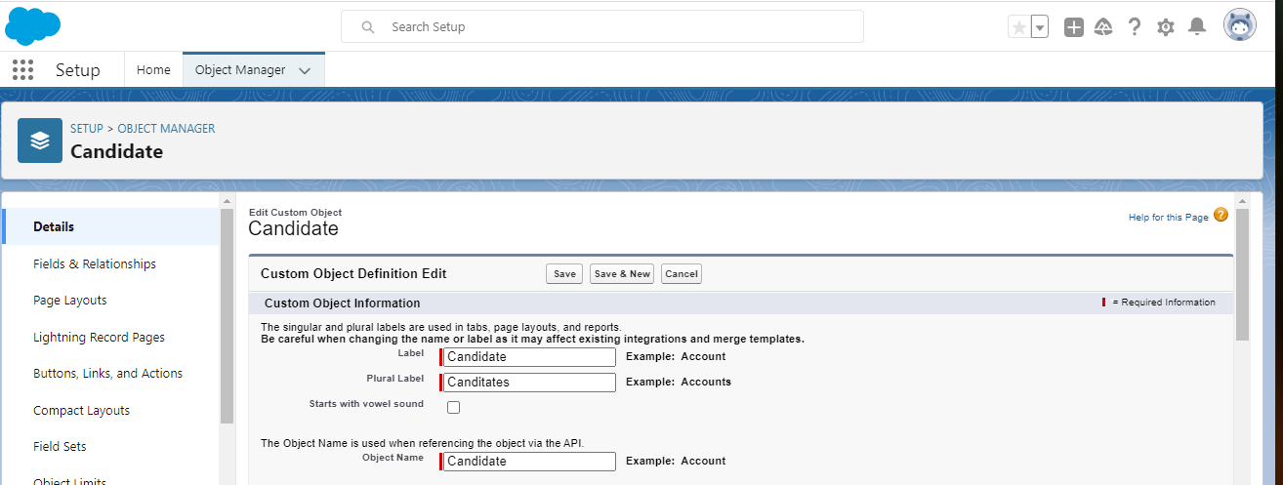

**Internal Results**

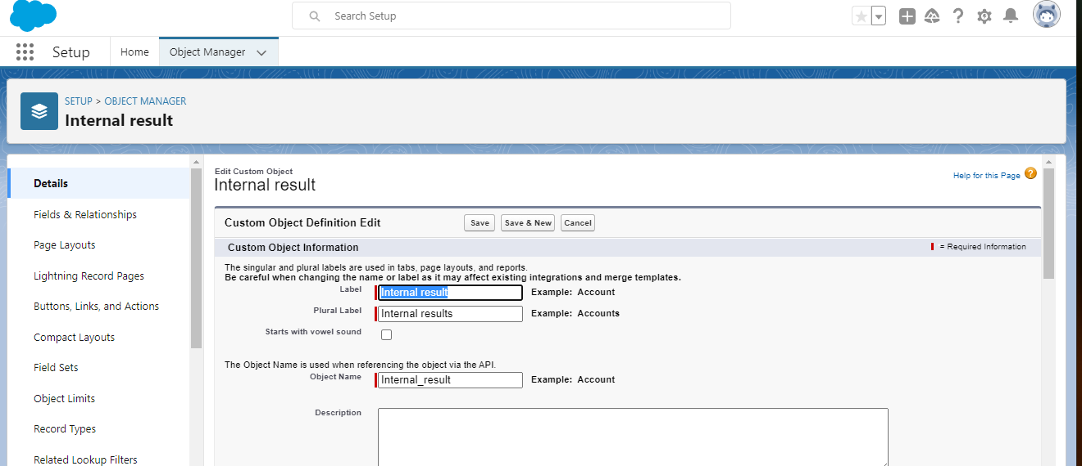

**Lecturer Details**

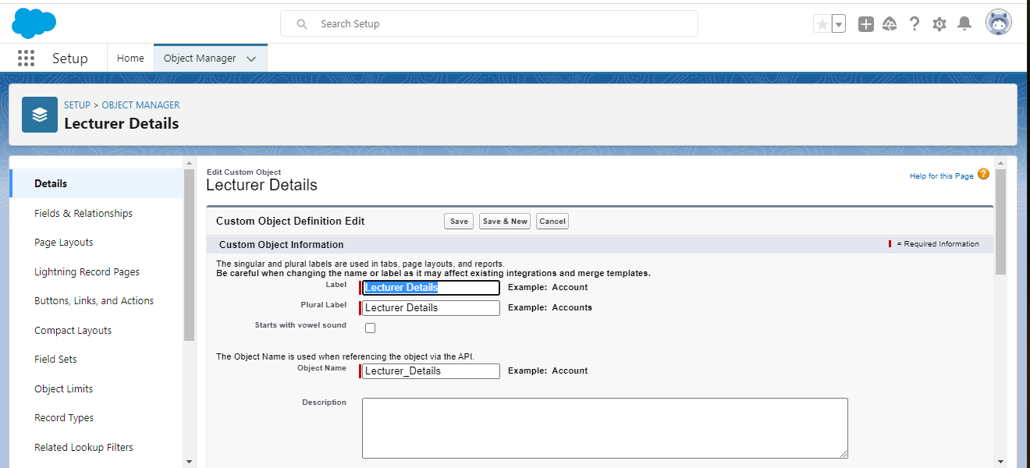

**Course Details**

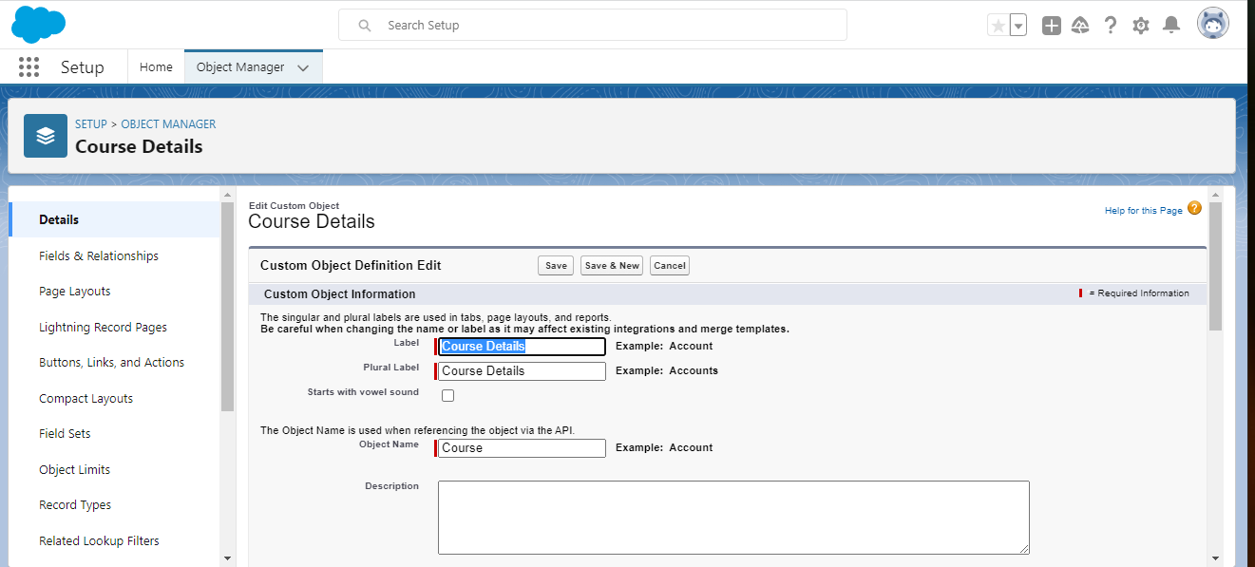

## 25.PNGTabs

Tab style, Select any style

## Fields and Relationship

An object relationship in Salesforce is a two-way association between two objects. Relationships are created by creating custom relationship fields on an object. This is done so that when users view records, they can also see and access related data.

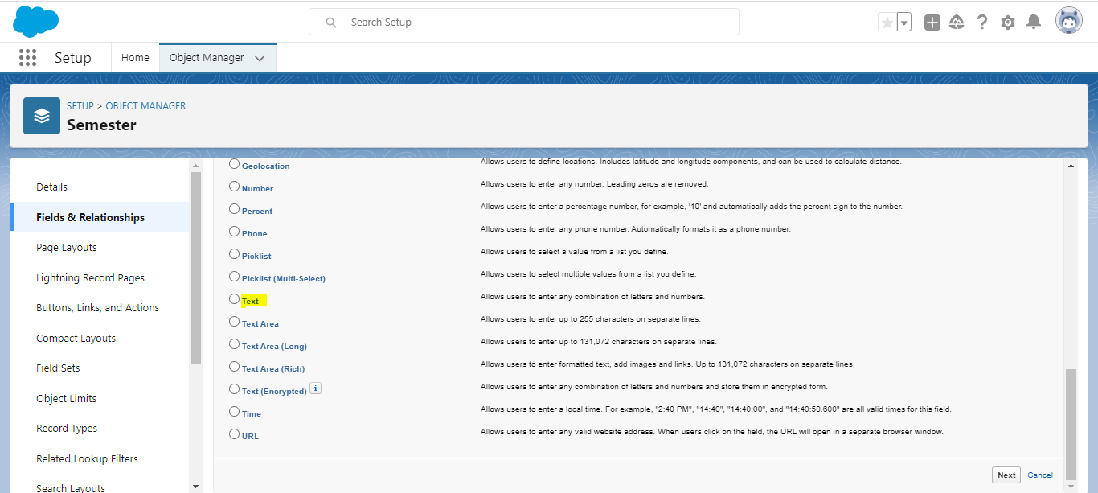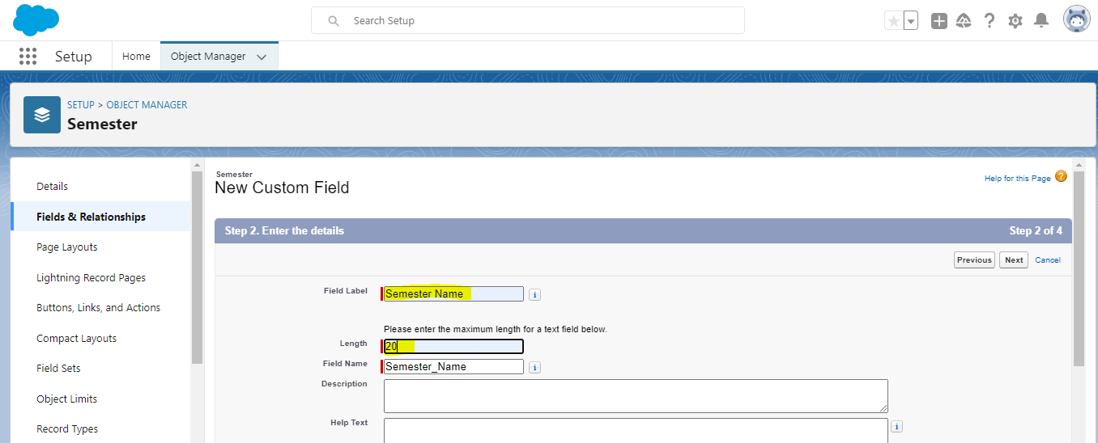

## Similarly Create Following Fields according to the objects.

|  |  |  |  |  |
| --- | --- | --- | --- | --- |
| Semester: | Candidate: | Course  Details: | Lecturer Details: | Internal  results |
| Semester Name | Candidate  Name | Course Name | Lecturer Role | Candidate  ID |
| Course | Candidate Name | Course ID | Lecturer Name | Course ID |
|  | Semester  Name |  | Course ID | Marks |
|  | Internal  results |  | Course |  |

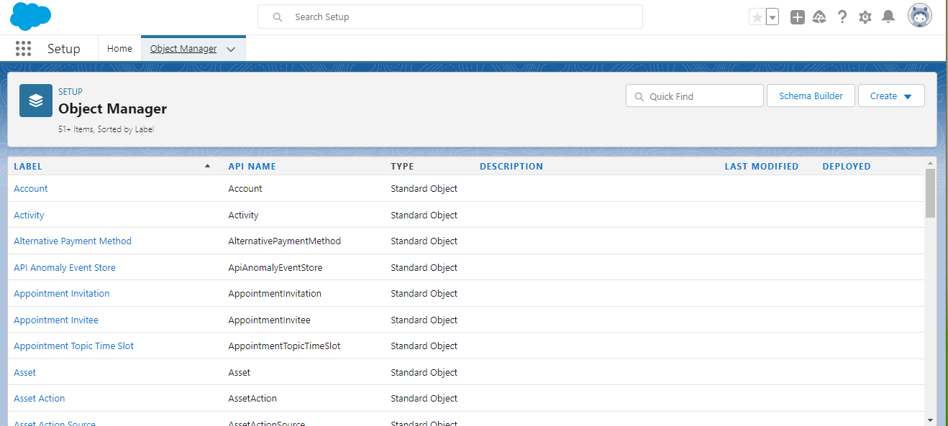

## 26.PNG28.PNG

## Lightning App

Apps in Salesforce are a group of tabs that help the application function by working together as a unit. It has a name, a logo, and a particular set of tabs. The simplest app usually has just two tabs.

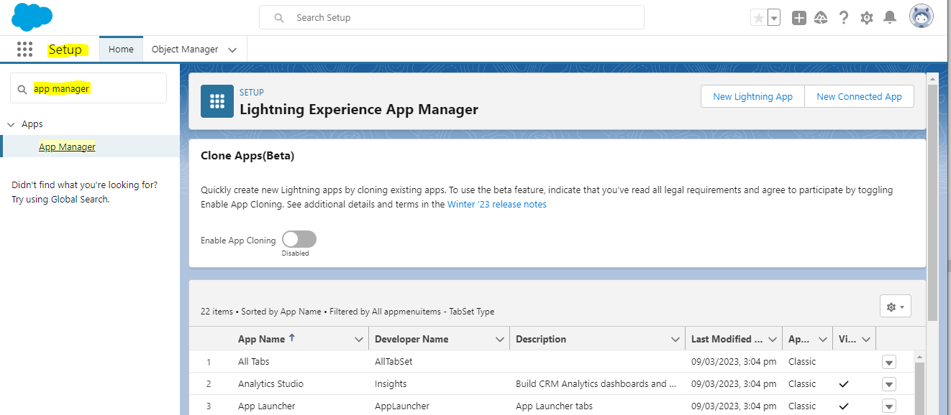

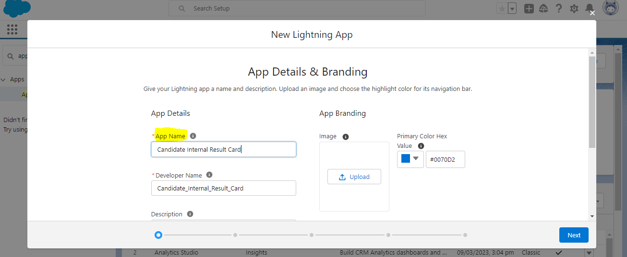

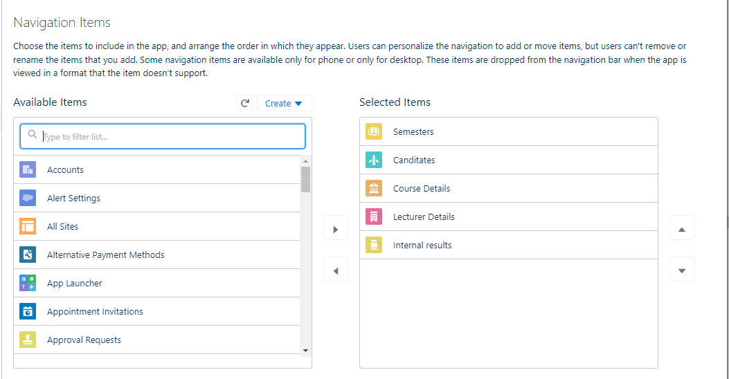

## Users

A user is anyone who logs in to Salesforce. Users are employees at your company,

such as sales reps, managers, and IT specialists, who need access to the

company's records. Every user in Salesforce has a user account.

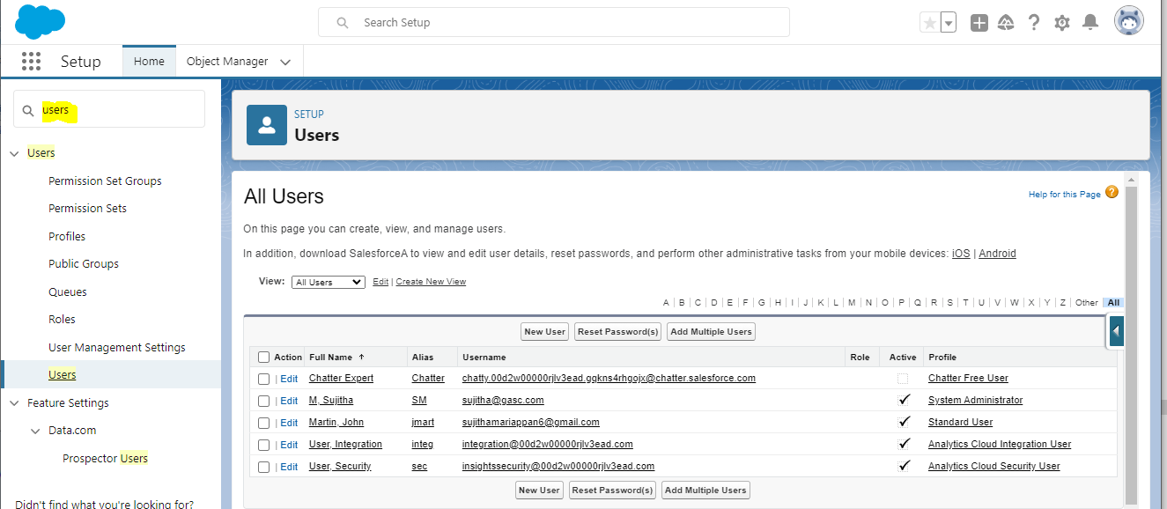

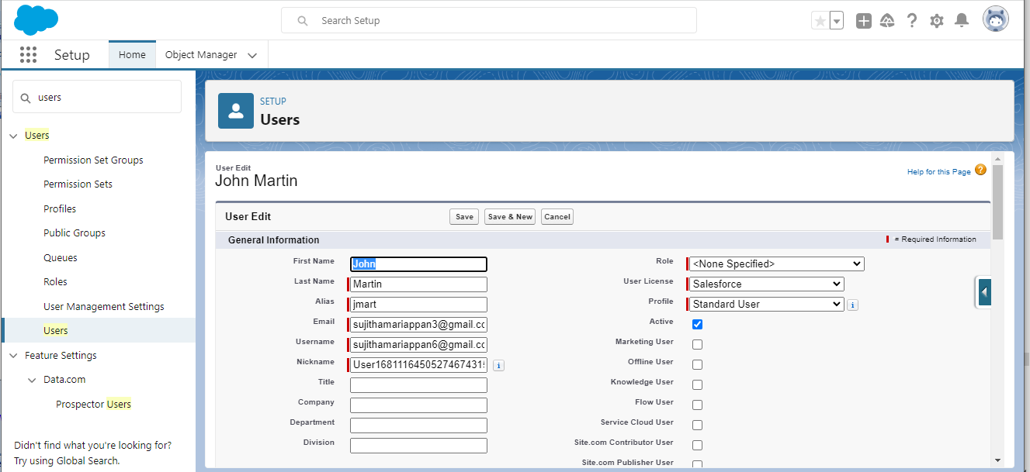

## Reports

A report is a list of records that meet the criteria you define. It's displayed in Salesforce in rows and columns, and can be filtered, grouped, or displayed in a graphical chart. Every report is stored in a folder. Folders can be public, hidden, or shared, and can be set to read-only or read/write.

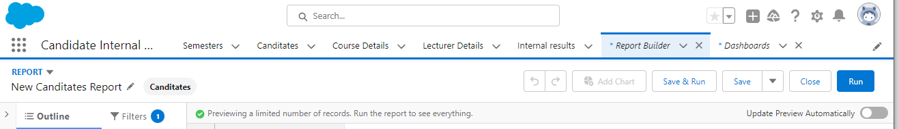

## Dashboards:

Dashboards let you curate data from reports using charts, tables, and metrics.

If your colleagues need more information, then they're able to view your

dashboard's data-supplying reports. Dashboard filters make it easy for users

to apply different data perspectives to a single dashboard.

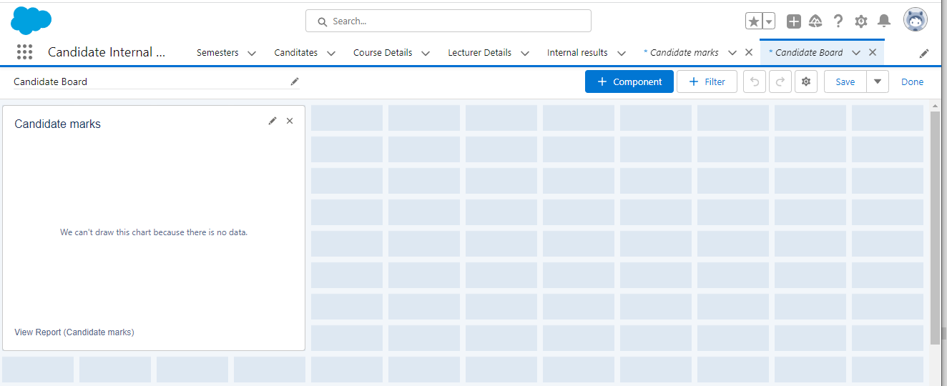

# TRAILHEAD PROFILE PUBLIC URL

TEAM LEADER : M.SUJITHA ; https://trailblazer.me/id/sujim13

TEAM MEMBER 1: T.Subbulakshmi; https://trailblazer.me/id/subbt3

TEAM MEMBER 2: N.Snega Devi ; https://trailblazer.me/id/snegn

TEAM MEMBER 3: P.Palaniammal; https://trailblazer.me/id/ppalavesam

# ADVANTAGES

* Faster Results.
* Error Free Results.
* It Motivates Students And Gives Them An Accurate Indication Of Their Academic Performance.
* Bias-Free Checking Of Marks.

# DISADVANTAGES

* Minor Technical Glitches In The System.
* Open Text Questions Cannot Be Graded.

# APPLICATIONS

Administrator should be able to create all base data including Semester, Candidate, Course and Lecturer, Lecturer should have the ability to create Internal Results, Dean, who is one of the Lecturer, should be the only one with ability to update Internal Results, Re-evaluation Can be initialized by Candidate for all Internal Results. Now only dean can update the marks after re-evaluation.

# CONCLUSION

By using the app, students will benefit. It is designed so that students can know their results in an easy way.this app saves time of the students the cost of the results.

# FUTURE SCOPES

This app saves the this would be best idea to implement

this app everywhere in the future.In future it would be implemented in all fields. Notification should be sent within seconds to respective authority.within seconds employees knows the result.This would save the cost greatly. This app would be in every fields in the future.